TRINITY EVANGELICAL
LUTHERAN CHURCH
TOPTON, PENNSYLVANIA
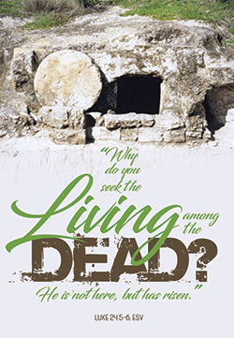

Reverend Laura Stoneback
610-641-8992

Dear Friends,
In her book, Kneeling in Jerusalem, author Ann Weems writes the following entitled LENT.

“Lent is a time to take the time to let the power of our faith story take hold of us, a time to let the events get up and walk around us, a time to intensify our living unto Christ, a time to hover over the thoughts of our hearts, a time to place our feet in the streets of Jerusalem or walk along the sea and listen to his word, a time to touch his robe and feel the healing surge through us, a time to ponder and a time to wonder…. Lent is a time to allow a fresh new taste of God!”

Lent is the time to take the time. How true and how necessary this statement is. I hope that you are rewarding yourself with the gift of time to review, pray about, and grow in faith. I hope you are taking time to hear once again about the love of God given to us in Jesus Christ. I hope you are seeking to grow in your discipleship and ponder the mystery of the Man-God, Jesus.

As we move closer to Holy Week, I want to encourage you to take the time to place yourself in the events of this week of love and passion. On Sunday April 14, we will receive palm branches and join in the shouts of Hosanna, only to soon find ourselves in the midst of the passion story. Each one at worship will personally take part in this story.
Our Holy Week services continue with a traditional Maundy Thursday service in which we celebrate the Lord’s Last Supper. On Good Friday, we will have the procession of the Cross during which time we hear both words of God’s love, and words of our betrayal. This service is a very meaningful and moving service and sets the tone for our joyous celebration of Easter day. We will have one service on Easter at 9AM.

My prayer is that all of us would allow the power of our faith story to take hold of us in a deep and rich way. May God’s Spirit call us to faithful discipleship as we bless and serve God in thought, word and deed.
Growing with you in faith,
Pastor Laura

Trinity’s Hand Print Graffiti Tells a Story of Commitment
If you have ever visited Trinity’s third floor, you’ve noticed that the hallway walls feature an unusual decorating motif. The wall features the handprints of students who have completed our Confirmation program over the years. The tradition was started several years ago. There are currently over 60 handprints on the wall, interlaced between messages of Christian encouragement. The symbolism is clear; all those who’s handprints are upon the wall are part of “Trinity’s Family of Faith.”

You are invited
We now extend to you the opportunity to “make your mark” upon the wall. All Confirmed members of Trinity are invited to place their handprints upon the wall, regardless of how long ago you were Confirmed. In doing so, you send a strong message to our Confirmation students that YOU are fulfilling the promise made to them at their Baptism; to support their Christian education.

How and when?
The supplies needed are already in the hallway; a selection of water-soluble paint, brushes and clean-up supplies. The ideal time to “make your mark,” would be immediately after Sunday worship services. If that is not convenient, just contact the church office and we’ll help you select a day and time.

What Easter does
Jesus’ resurrection from the dead is life-changing and life-giving for his followers. But, as Henry Knox Sherrill notes, Easter’s “joyful news … does not change the contemporary world.” On earth, we still must deal with sin, pain, death and brokenness. And “still before us lie work, discipline, sacrifice,” Sherrill adds. What Easter does, though, is provide Christians with “the spiritual power to do the work, accept the discipline and make the sacrifice.” By defeating the grave, Jesus empowers us to bear our worldly troubles with joy, peace and hope. His resurrection assures us that trials, tears and suffering are only temporary, while eternal victory and life with Jesus are permanent.
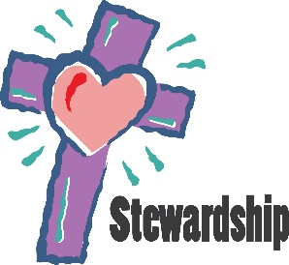
STEWARDSHIP….it’s what we do after we say, “I believe”.
Over the years, stewardship has almost been a dirty word in the church, and as Pastor, it was often one I was afraid to use. I am glad that is no longer the case. You see, I have grown in many ways during my years of ordained ministry. Hopefully, I am a better preacher, better planner, better listener, and better steward. As a pastor, I am called to make disciples (not church members, but disciples of Jesus). One cannot separate discipleship from stewardship.
When we confess that we believe in God the Father, God the Son and God the Holy Spirit, we are confessing that God created us and all things, that God redeemed us from our sinful nature and that God journeys with us throughout our life. In other words, all that we have and all that we are come from God. Discipleship is using what God has given us for the glory and work of God.
The topic Jesus most preached on in the Bible is the topic of money. How smart he was to know that one of the things, in fact, the number one thing that separates people from true devotion to Jesus is their love of money, and trusting in money more than anything else. So, like a good coach, Jesus reminds us and encourages us to see God’s goodness and faithfulness at all times and to realize that God does provide for our needs, while using us to do God’s work here on earth.
So, just some questions for you to ponder:
Do you joyfully give your offering to the church?
Do you faithfully give your offering…after all, God is with us 24/7..not just on the days we show up for worship.
Do you want to grow in your relationship with God, perhaps trust God and depend on God instead on yourself?
Stewardship, it is what we do after we say: I believe.
UPCOMING WORSHIP SCHEDULE
Wednesday, April 3rd – 7PM Lenten Bible Study

Saturday, April 6th – NO SATURDAY NIGHT WORSHIP

Sunday, April 7th – 9AM Worship/Holy Communion

Wednesday, April 10th – 7PM Lenten Bible Study

Sunday, April 14th – 9AM Worship/Holy Communion Palm Sunday

Thursday, April 18th – 7PM Worship/HC

Friday, April 19th – Worship

Sunday, April 21st – Easter Sunday The Resurrection of Our Lord
9AM Worship/Holy Communion

Sunday, April 28th – 9AM Worship

Saturday, May 4th - 5:30PM Worship/Holy Communion

Sunday, May 5th – 9AM Worship/Holy Communion

Mutual Ministry committee
Do you have joys or concerns about Trinity you would like to share with others? Trinity has a mutual ministry committee as a means to help you in your communications. Please take your joys or concerns to Terry Schartel or Mike Grossman or Pastor Laura.

Thank you to Pastor Laura Stoneback for her visits, prayers and phone calls during my recent illness.
Betty Bleiler

Mid-week Lenten study
7pm Wednesday evenings

As Lent is a time of spiritual discipline and study, I encourage you to plan to join us at Trinity on Wednesday evenings throughout Lent. On Ash Wednesday, Pastor Hahn will lead worship which will include the imposition of ashes and Holy Communion.

Beginning on Wednesday March 13th, Pastor Laura will lead us through a DVD series called: 24 Hours That Changed the World. Please join in the learning and fellowship as together we learn more about Jesus last 24 hours on earth. The DVD portion of each evening is set in the Holy Lands and will bring new understanding to the historical and spiritual events of Holy Week. Our gatherings will be informal, held in fellowship hall. Please invite neighbors and friends to join in the course. You may order the book if you wish ($9.99 for an e-book), but it is not required. Classes will be held each Wednesday in Lent beginning at 7pm. Even if you need to miss a class or two, come to the others. You will not regret it.

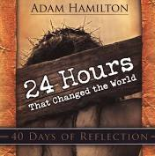
Adam Hamilton guides us, step by step, through the last 24 hours of Jesus’ life in his popular, heartbreaking, and inspiring book.
No single event in human history has received more attention than the suffering and crucifixion of Jesus of Nazareth. In this book, Hamilton will help you experience and understand the significance of Jesus’ suffering and death like never before. He retraces the day that changed human history in his usual straightforward yet easy, conversational style that speaks to both long-time Christians and those who are simply curious about the story of Christ’s crucifixion.
Adam Hamilton combines biblical story, historical detail, theological analysis, spiritual insight, and pastoral warmth to retell the narrative of Jesus’ last and greatest hours. - Leith Anderson, author of The Jesus Revolution
At the March council meeting, the church council spent quality time reviewing the ministries of Trinity. This time enabled us to celebrate the ministries that are fruitful, and reflect on and brainstorm about those areas which need improvement. In our discussion, one area in which our church is negligent is in caring and supporting young families. One very concrete ministry which would help in this area is nursery care during the worship service. As we seek to provide a stress-free and meaningful place for parents to draw into deeper relationship with God, we need to provide this service. Please step forward and volunteer for this important ministry of your congregation. You have been blessed in order to be a blessing to others. If you are willing to take a turn in the nursery, please let the church office, Pastor Laura or any council member know of your willingness to serve. Thank you!

HOW DO I OFFER MY FIRST FRUITS UNTO THE LORD?
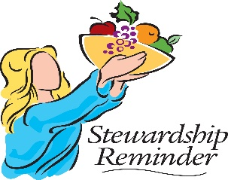
Throughout scripture, God’s people worshiped the Lord by offering back to God their first fruits. Though life was and is full of uncertainties, God’s people trust in God to provide. For the people of God, it is shameful to offer to God “left-overs”. So, how do you worship God through your offering? When payday rolls around, automatically set aside a percentage of your pay (a biblical tithe is 10%) and place it in your church envelope, or set up an on-line giving account. Our offering should be joyful and a means to worship and praise the God who saved us from the power of sin and death, and leads and guides us each and every day.

Christian Education News!
The confirmation retreat is scheduled for May 17-19th at Bluff Island. Look for more details in the future.

Confirmation is scheduled May 26th. Pastor Hahn will be performing the service that day. Please remain after the service for pictures. Refreshments will be served in the social hall after pictures.

Confirmation students will meet with Pastor Laura individually prior to confirmation.

Attendance at church and Sunday School is highly encouraged for the remainder of the year.

PLANNING FOR VACATION BIBLE SCHOOL HAS BEGUN! We will be hosting VBS this year. If you are interested in helping or teaching at VBS, please contact the church office.

Adult Bible Study after Church
We want to invite you to join us for a story you may not have heard before. It’s the story of the Bible. We all know stories from the Bible … but how did the Bible come about? Why was it written? Who wrote it? When was it written? How was it assembled? Didn’t it just come from God.? Do you want to find out once and for all? Join us on Sundays after the service as we explore some of these questions and more. You’ll be fascinated … inspired … and exhilarated by what we learn.
It will be 45 minutes long and starts immediately after the service. So join us … you’ll be glad you did. All are welcome!

Mid-week bible study with Pastor Hahn will resume after Easter.

WORSHIP & MUSIC
The next Worship and Music Comm. meeting will be April 1, 2019 @ 7 PM.

Next Saturday evening service will be May 4, 2019 @ 5:30 PM.

REMINDER: NO Saturday evening service April 6, 2019 due to Lenten season.

CHOIR NOTES:

SENIOR CHOIR: Practices will be April 4th, 11th, and 25th @ 7 PM.
Holy week may practice Wed. 4/17 @ 7 PM- TBD

CHILDREN'S CHOIR: Practices will be held prior to Sunday School @ 10:30 AM.
Dates to sing: TBD

ADULT BELL CHOIR: Rehearsals will be March 24th, April 7th & 14th @ 10:45 AM.
Will be ringing April 21st (Easter).

CHILDREN'S CHIME CHOIR: Practices will be March 24th, April 7th @ 10:15 AM.
May ring on April 14th (Palm Sunday)
**NEED CHILDREN TO RING CHIMES- PLEASE JOIN US FOR GREAT FUN**
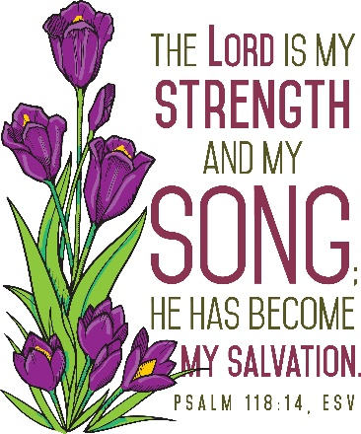
Always looking for more ringers and singers for all of the choirs!!!
Come join the fun and fellowship of our church family.

God Bless and Peace
Happy Easter to all of our church family
Steve and Wanda

Office Hours for April:
April 1 – 1:00 -6pm
April 2 – 9-5pm
April 3 – 3:30 – 5:30pm
April 4th – 3:30-5:30pm
April 8th – 8:30-1pm
April 9 – 12 – 5pm
April 10 – 3:30-5:30pm
April 11 – 3:30 – 5:30pm
April 15 -16th Office closed
April 17th – 5-8pm
April 18th 3:30-5pm
April 19th – 8-Noon
April 20th – 12:30-3:30pm
April 22nd – CLOSED/Holiday
April 23 – 9 – 5pm
April 24th - 3:30-5:30pm
April 25th – 3:30-5:30pm
April 29th – 9:30-5pm
April 30th – 10 - 5pm
May 1st – 3:45pm-5:45pm
May 2nd – 3:45pm-5:45pm

Have you changed your phone number or email address? Please be sure to let the church office know of any new information. It only takes a minute. Thanks!

Congratulations and blessings to Eric and Sara (Damman) Appleman. Eric and Sara were united in marriage on Saturday, March 2, 2019.
The Social Ministry Committee will be holding an egg hunt for the children of Trinity on Palm Sunday, April 14th at 11AM. It is for children ages 0 – 12 years. Weather permitting it will be held outside of the church. If it rains, it will be held inside. The committee is currently looking for the following items for the egg hunt: bubbles, coloring books, stickers, chalk, washable markers, washable paints, crayons, stuffed animals, wrapped candies, wrapped chocolates, chocolate bunnies, and books for various ages. The items can be placed in the large Easter Basket in the overflow area of the church. Thanks for your generosity in advance!

The final word
When wildfires ravaged Paradise, California, in 2018, dozens were killed and thousands lost homes, irreplaceable mementos and personal connections. School, work and church routines were upended.
If life has both “cross-like times” and “resurrection-like times,” as a pastor once said, this certainly was a cross-like time. But God never lets death, sorrow or suffering have the final say. To bring light to dark times, God works through countless good-hearted helpers.
One was 90-year-old Bob Wilson, a Los Angeles man who quickly decided to give people he’d never met “something ... [to] lift their spirits.” That “something” was a $1,000 handwritten check for each of the 1,085 students and staff members at Paradise High School. The checks, which came with no restrictions, were presented at a gathering that felt healing to many.
Cross and resurrection times are interwoven in this life, but the cross doesn’t win. One day, God promises, resurrection will have the final word.
FEBRUARY FINANCIAL UPDATE:

Total Income for February: $11,134.95
Total Expenses for February: $10,373.04
$761.91

*Please note that Trinity received $1,465.27 in donations through Thrivent Choice Dollars and Amazon Smiles in February which is not income we receive on a monthly basis*

APRIL FLOWER SPONSORS
7TH – Mary Luckenbill in Memory of Luther Luckenbill
14th – Andrea Moyer in Honor of Chase Moyer’s 14th Birthday
21st – Harry & Darla Moyer in Honor of the Grandchildren and in Memory of Loved Ones.
28th – OPEN

APRIL BULLETIN SPONSORS
7TH – Steve & Debbie Reinhard in Honorof Grandson J.P.’s Birthday
14th – Andrea Moyer
21st – Eric and Elisa Moyer in Honor of Elisa’s Birthday
28th – Nancy Guldin in Honor of Goddaughter Amey Ann Ruth’s Birthday

ETERNAL FLAME SPONSORS
Bonnie & Kap Stauffer
Meanings in the meal
Jesus instituted Communion while celebrating the Jewish Passover with his disciples. The meal’s ritual foods hold meaning for Christians, too, because our faith story is interwoven with that of Judaism.
Matzoh: This unraised bread recalls the Israelites’ hasty departure from oppression in Egypt. Jesus used the Passover bread to symbolize his body, which delivers us from bondage to sin and death.
Salt water: It symbolizes the tears of the Hebrews and of all who suffer in any time and place. Christians believe that in Jesus, God embraced human suffering so we need never face it alone.
Parsley: Dipped in the salt water, this green, leafy vegetable represents the Hebrews’ rebirth out of sorrow into the joy of freedom. Easter’s celebration of resurrection proclaims a coming day when God “will wipe every tear from [our] eyes [and] there will be no more death” (Revelation 21:4, NIV).
Shankbone: A lamb slaughtered for each Hebrew household meant life for those within. The meat strengthened them for the escape journey, and the blood, swabbed on their doorframe, signaled for Death to “pass over.” Jesus used wine at the Passover meal to symbolize his blood — of the Lamb of God — which he would shed for our salvation.
Egg: For Jews celebrating Passover, an egg symbolizes memory of the Exodus and renewal of faith. For Christians at Easter, eggs — especially open, empty ones — call to mind Jesus’ empty tomb, renewal and abundant life.

ONLINE GIVING - HOW DO YOU SIGN UP?

1. Visit our church website at www.trinity-topton.com
2. Click on the Donate Tab
3. Scroll down to the bottom the page for the Online Giving link
4. Click on green tab “Create New Account” to get started

If you have any questions, please contact the office.
Download the Online Giving app for even more convenience.

Boyer’s Tags – When shopping at Boyer’s, don’t forget to swipe that tag! Trinity receives a percentage of every sale swiped with a Boyer’s tag from Trinity. If you do not have a tag, there are a few located in the coatroom.

Radcliffe Receipts – Please bring in Radcliffe receipts. Receipts must be dated within a year of the current date. All proceeds earned will be designated to Trinity’s Building Fund. Drop-off boxes are located inside the Home Ave. entrance and in the coatroom

Thrivent Choice Dollars - Members become eligible for Thrivent Choice based on insurance premiums, contract values and Thrivent volunteer leadership. Members are able to direct Choice Dollars to enrolled charities. With Thrivent Choice®, you can recommend where some of Thrivent Financials’ charitable outreach funds go.

Amazonsmile.com – Shoppers can now designate Trinity as the non-profit organization that can receive a percentage of their sale. Logon to Amazonsmile.com when making your future purchases. Thank you
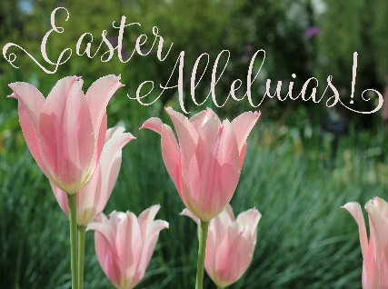
Tomb, thou shalt not hold him longer;
Death is strong, but life is stronger.
Stronger than the dark, the light;
Stronger than the wrong, the right.
Faith and hope triumphant say,
Christ will rise on Easter Day.
—Phillips Brooks

SYNOD NEWS
May 4. Ministry Fair. 9:00 a.m. – 1:00 p.m. at The Lutheran Center (Lunch will be provided). Visit the Synod’s Resource Center to learn about ministries of the Northeastern PA Synod; share resources offered by synod teams; and attend mini-sessions (like Learning Ministries Day). There will also be an opportunity to share your congregation’s information/ministries at your own sharing table. Sponsored by the Faith Formation Resource Ministry Team. For more information, visit the synod website at http://nepasynod.org/event/ministry-fair.
May 5. May Play Day. Join others from around the synod for the annual May Play Day! What can you expect? Games for all ages. Adventures: rock-climbing wall, boating, hiking, high ropes course and more. Dinner and singing. For senior high youth and their advisors/parents – an info meeting on the 2018 youth gathering and the synod’s Lutheran Youth Fellowship organization. The cost is $4 for children who are 12 years and younger. For everyone else the cost is $8. Explore the camp – rain or shine – and enjoy a fun day outdoors. For more information and to register, please visit the synod website at http://nepasynod.org/event/may-play-day.
June 1. Synod Assembly. “Freed in Christ for a New Day.” Genetti Inn and Suites in Hazleton. This is a one-day event. Registration cost for voting members will be only $100, while visitors this year will pay $20 (which covers the cost of the full luncheon). Any and all are encouraged to attend. More information will be placed on the synod website as it becomes available.
November 5-6. Bishop’s Conference 2019 – Save the Date! “Letting Go of Certainty in Order to Survive.” Presenter: Dr. Peter Enns. Shawnee Inn and Golf Resort. Download a poster.

WARM BIRTHDAY WISHES SENT YOUR WAY!
1st – Heidi Hermany and Anna Reed
2nd – Jacob Fenstermacher and
Kermit Fisher
4th – Laura Eckhart
5th – Camden Carl and Donna
Leister
6th – Kyle Letterman
7th – Trevor Moser
8th – Dylan Hoch
12th – Kassi Yocco
14th – Mark Moyer
16th – Jamie Harpel and Dakota Rupp
17th – Leslie Grossman
18th – Chase Moyer
19th – Austin Loring
20th – James Hubble
21st – Barbara Epting and Carl Wischner, Sr.
22nd – James Gerhardt
23rd – Kim Borrell and Brenda Knight
24th – Patrick Coine and Mary Fegley
25th – Harlee Frantz and Savannah Tobias
26th – Devin Grow and Zachary Tobias
28th – Phil Roth and Ethan Stuckley
29th – Deborah Reinhard and Cindy Ruth
30th – Melissa Aguado and Nancy Guldin

If a name has been missed on this list or is incorrect, please contact the church office.

We are in need of volunteers on the LAY Schedule. If you would like to volunteer to greet, usher or read at worship services, please contact the church office.

We are also looking for someone to coordinate the lay schedule on a monthly basis. The role of this person would be to assign people to dates and duties on the lay schedule and provide that list to the church office by the specified newsletter deadline.

UPCOMING COMMUNITY EVENTS

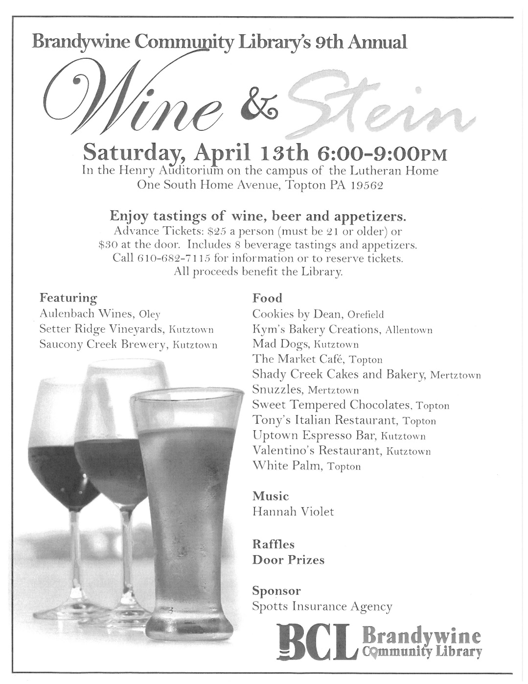

2019 Seed Potato Cutting!
2019 Season Seed Potato Cutting; April 27th & 28th, 1-4PM each day at Becker's St. Peter's Lutheran Church, 265 Maidencreek Rd., Fleetwood (Molltown) PA 19526.

Public Invited - ALL COME! We need the help. We will be cutting Seed Potatoes for immediate planting, intended for Fall Harvests. - All donated for local hungry neighbors in need. This is a Barebones Event. Bring your own snacks and drinks, cutting board and steak knife. This is a Rain or Shine Event. Cutting inside the church building and outside too if the weather is nice. Just show up, walk-in and help!

Visit the Website: http://www.IHartHarvest.org and Facebook: @potatoproject
Rev. Bruce Osterhout says, "Bring a donation if you can, we're poor."
See Session Example: https://sites.google.com/view/ihartharvestinc/home/calendar/seed-potato-cutting
Please come and help.

DID YOU KNOW TRINITY HAS A FACEBOOK PAGE? Please like us at Trinity Topton.

