TRINITY EVANGELICAL
LUTHERAN
CHURCH
TOPTON, PA

Please join us and special guest author, Tim Kreider, on Sunday, November 18th at the
9 a.m. worship service. Fellowship to follow the service.

Technology Survey and Poinsettia order forms are enclosed in this publication.

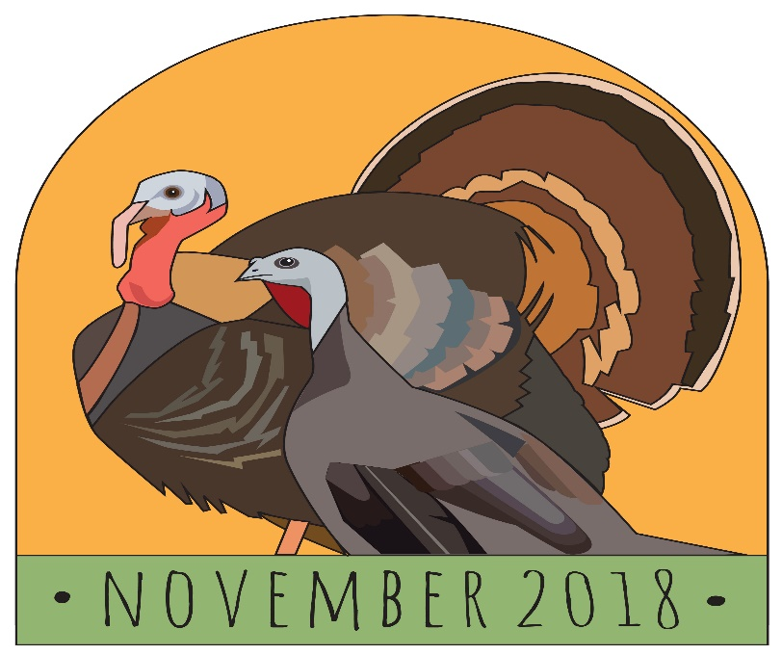

FLOWER SPONSORS
4^{TH –} Judy Bond in Memory of Michael Bond
11TH – June Fisher in Honor of her Birthday and Veteran’s Day
18TH – Steve Schucker
25TH – Sue Radclilffe Trexler and Julie Radcliffe Atallah in Memory of Earl Trexler.

BULLETIN SPONSORS
4TH – Eric and Elisa Moyer in Honor of Leon’s 3rd Birthday
11TH – June Fisher in Honor of her Birthday and Veteran’s Day
18TH - OPEN
25TH –OPEN

ETERNAL FLAME – Nancy Guldin in Loving Memory of her husband, Reynold J. Guldin, parents Mr. and Mrs. Karl Fritch, grandparents Mr. and Mrs. George Epting and other Loved Ones

If you would like to sponsor flowers, please contact the florist of your choice. If you would like to sponsor bulletins for a week, the cost is $20.00 per week. If you would like to sponsor the Eternal Flame, the cost is $20.00 for the entire month. Thank You
If there is a week that is listed as OPEN, that means no one is currently sponsoring. If you would like to be a sponsor, please sign up on the Flower and Bulletin Charts in the vestibule.

Flower and Bulletin Charts for 2019 will be available on Sunday, November 4th.
Letter from the President
Sometimes God splits the seas. Other times, he pulls what has been split back together, and stitches it up. (Shannan Martin, “The Ministry of ordinary places)

In the book of John, we read about John and Andrew as ordinary men who by the power of the Spirit recognized Jesus as the Lamb of God. Compelled by his presence, eager and curious, their first questions were stunningly basic. Who was He, really? How did He live?
Jesus’ response? Come and see. John 1:39
No surprise, the Son of Man (Luke 7:34) led with an invitation to open their eyes and join Him in the work of the kingdom. Are we doing that? At Trinity, you can witness it happening. “God’s work. Our hands” is more than words on a bracelet.
The life of Jesus tracks a sensory-rich narrative. We read in Luke of burning incense, of chanting crowds, and angel voices booming; of dusty roads, many shepherds, and a young girl who was “obviously pregnant.” Heaven came down as a Baby with dimpled hands and a dark swirl of hair and soon, men were tracking the night sky, wide awake with wanting.
Jesus grew, drawn to the wildest ones, those most likely to be written off as unfit, unworthy, in need of a lesson on the ways of blending in with the religious culture surrounding them. Do you see yourself, your family, your neighbor in that group? Have hope.
By no mistake, it was John the Baptist who plunged Jesus’ head into the water, upsetting authority and the cultural code. Where the world saw an untamed man, crazed, insane, disgusting, and disrespectful, Jesus saw a worthy protest, choosing him as his line in Galilean dust.
Jesus came to us as a person with eyes, ears, a mouth, a nose, fingerprints and hair follicles. He cried. He feasted. He walked until his feet ached. He reached back after a long day and squeezed the tension from His own sun-weathered neck. He got goose bumps. He took naps. He felt alone sometimes, because He felt alive.
He engaged the world by paying attention to His corner of it and really being with the people near him. He chose well by choosing the humble and the overlooked. He is asking the same of us.
continued
A life hidden in Christ means we will continuously crave more of God. The good news is, He’s in the faces we see and in the stories we hear which are playing out in the most ordinary of places.
Though He doesn’t need us, He wants us near. And so, the invitation stands.
Come. See. Think about it: Jesus came to be near us . . . the wild ones, the written off ones, the unworthy ones. He put on bones, wriggled into a suit of flesh, and slipped into fragility and weakness. For us. To know us and be known.
Come and See at Trinity! Come to Sunday’s services; Sunday school; Catechetical class; Bible study; serve Jesus by being his hands and feet to spread the good news: Christ is alive and he lives in all of us.
Peace,
Dave Ehrig, Council President

Saturday, November 3rd 5:30pm Worship/Holy Communion

Sunday, November 4th 9AM Worship/Holy Communion
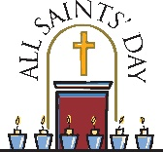
All Saint’s Sunday
Sunday, November 11th 9AM Worship
Veteran’s Day Breakfast
Sunday, November 18th 9AM Worship
Special guest Tim Kreider
Fellowship to follow in the Social Hall
Sunday, November 25th 9 AM Worship/HC
Christ the King Sunday

Pastoral Emergency Contacts for November – in the event of a Pastoral emergency, please contact:
October 31st – November 10th – Pastor Arthur Hahn 610-682-2060
November 11th-21st – Pastor Doty -484-553-1162
Please check weekly bulletins for changes or additions to this schedule.
TAKING THE STEW OUT OF STEWARDSHIP
I have been asked to offer some thoughts and reflections on the topic of that often dodged Biblical concept of Stewardship. In studying the Cain and Abel story we get to the root of it all. It has to do with ATTITUDE. Remember, Cain offered his sacrificial portion of the farmer's crop to God which was rejected. Why? Because Cain had an attitude of greediness giving God the poorest and least of HIS crop. This was HIS crop HE worked hard for and begrudgingly offered it to His Lord. It was kind of like his "CHURCH DUES". That wasn't bad enough........ So his brother Abel finds favor with his Lord, God by giving a portion of God's herd as a sacrifice of JOY for all his Lord had given him including God's HERD OF ANIMALS....not his. True Offering is a kind of communication of THANKSGIVING and JOY to our Lord for all he has given us.
Is it any wonder the first Murder is recorded because of jealousy and hatred over the ATTITUDE of selfish giving vs. Abel's joyful giving. We at Trinity struggle over the financial problems of paying the bills and moving on. Soul searching is badly needed by all of us. Are we in Cain's Camp of giving begrudgingly to our Lord and His work, or do we find ourselves in Abel's camp of Joyful giving to our Lord who has given us all we have. If we take the Stew out of Stewardship....... our Church Council meetings will be much shorter. And we can focus on building and strengthening the SPIRITUAL RELATIONSHIP our Father, God so desires with our Glorious Lord and Savior Jesus Christ.
Stewardship is what happens after we say "I believe"! Peace going
forward.
Art Hahn, Pastor Emeritus

Prayer List: Betty Bleiler, Elaine DeLong, Goldie Geist, Betty Hertzog, Marjorie Moyer, David Kistler, Debra Schlegel (Sister of Karen Epting), and Tommie Stoudt.
Prayer for Long-Term Healing: Dominic Aguilar, Leon Conrad, Janet Ferry, Daryl Gerhart, Marlene Hacker, Mae Hertzog, Dennis Hilbert, Pam Kelhart, Niki Nolte, Jackie O’Neill, Jackson Radcliffe, Rayanne Rauenzahn, Debbie Reinhard, Clifford Roth, Ella Smith, Gid Waterman, Brenda Younger, James Mabry and all of our military personnel, law enforcement officers and their families.

Please join us for the Veteran’s Day Breakfast on November 11th after worship. All are welcome. A food donation sign-up sheet and an attendance sheet are located on the table in the overflow area. If you are a Veteran, please contact the office 610-682-7352.

Angel Tree – Names will be available November 18th. Please return all gifts by December 3rd.

Breakfast with Santa will be held on December 8th at 9am. This event is for children ages 0-10 years. You can sign up for this event November 4th – 18th. The form will be in the overflow area. If you are unable to sign up at church, you can contact the office. Please leave a message with your child’s name, age, phone number and number of adults attending the breakfast. If you would like to donate food, the form is also in the overflow area.
We will be baking Christmas cookies for our shut-ins. We need volunteers to bake. Please have the cookies to the church by December 10th. We will deliver cookies on 12/12.
Social Ministry APPRECIATES any and all food donations. Without the congregation’s generosity, we could not hold these events. MANY THANKS!

Trinity’s Paint Can Collection! Give your old paint a new purpose!
Starting 10/21/2018, Trinity will be collecting leftover LATEX paint cans for our upcoming mural painting projects. Reduce, reuse and recycle! Please help our cause and our planet at the same time! We are collecting all size cans and colors, but only latex paint please. Whatever goes unused will be safely recycled! Please bring your paint starting 10/21/18 – Our church walls thank you in advance! The collection will be in the overflow area. Thank you to Meghan Quier and Leslie Grossman for leading this project!
Greetings,
I want to thank you for your patience as I transition back into a role that I worked in many years ago. There have been many changes, and I am working on learning those changes. Thank you to all who have been helping me along the way. There are many…and I thank all of you. I would like to specifically thank Marie for graciously answering questions whenever they arise. I also want to thank Wanda Golden & Steve Schucker for their help. Please check the newsletter calendar for specific office hours. Hours are also posted in bulletins and on the church door.
Please fill out the technology survey that was included in this publication. Please include email addresses and cell phone numbers for those aged 16 and older in the household on the form. Thank you! Andrea

WORSHIP AND MUSIC
The next Worship and Music Committee meeting will be held on November 12th at 7PM.
CHOIR NOTES:
SENIOR CHOIR: Practices will be November 1, 8,15 and 29 at 7PM.
CHILDREN’S CHOIR: Practices will be held prior to Sunday School at 10:30am. Dates to sing: To be Determined.
ADULT BELL CHOIR: Rehearsals will be November 4, 11, 18 (if need), December 9 and 16 at 10:45am. We will be ringing October 28, November 25th at the 9AM service and December 24 at the 9PM service.
CHILDREN’S CHIME CHOIR: Practices will be November 4th, November 18th, December 9th at 10:15AM. We will be ringing November 11th and 16th at the 9AM service and December 24th at the 6PM service.
We are always looking for more ringers and singers for all of the choirs! Come join the fun and fellowship of our church family.
Happy Thanksgiving to everyone.
God Bless and Peace
Steve and Wanda

Welcome to our Church Family, August Harold Volker. He is the son of Matthew and Devon (Fritch) Volker and grandson of Judy Fritch. He was baptized on October 6, 2018.
FROM: T-O-M (Trinity Outreach Ministry)
On Sunday, 10/21, we celebrated “Harvest Home” by wrapping up our 7-week donation project to our local food pantry. To all who participated, THANK YOU! This project ran in conjunction with the ELCA project “GOD’S WORK. OUR HANDS.” I can’t think of anything more appropriate that we could have done than to help those less fortunate than ourselves. Keep up the good work remembering that hunger is a year-round feed-need! We are considering establishing one Sunday per month as a food pantry donation Sunday – more news to follow!

Starting Sunday, October 28, we have a new project: winter caps or hats, coats, gloves, and socks which will be taken to Reading to be distributed to underprivileged children. Please join us for collections on Sunday, November 11th and Sunday, November 25th. Help us help young people to be a little warmer this winter season.

Finally, we invite you to participate in “Just A Drop in the Bucket.” In conjunction with a project of the North Eastern Synod of the ELCA, we are attempting to raise monies for the victims in Georgia and Florida of Hurricane Michael. During our church services in November and December, our young people will go through the congregation armed with buckets. Your part is to throw your pocket change (or bills if you prefer) into the buckets. Whatever we collect will be sent to the Synod for the victims of Hurricane Michael. (Of course, if you wish to donate a larger amount than just coins, you can do that also! Just drop it in the bucket!) We will start the campaign October 28th and do it every Sunday through December 30th.

Did someone say GIFT CARDS? We will again be selling SCRIPS Gift Cards as a fundraiser for Trinity. Order forms and a list of available gift cards for purchase are available on the overflow table or in the office. Orders/money are due 12/2/18. Checks should be made payable to Trinity. Any questions, please contact Debbie Reinhard

Welcome Addyson Charlotte Quier to our Church Family. She is the daughter of Jonathan and Meghan Quier. She was baptized on September 2, 2018.

TRINITY ELC FUND SUMMARY INCOME
Operational Fund Sept. 2018 2018 YTD
Ash Wednesday $ - $604.00
Benevolence $55.00 $1,114.50
Bulletins $ 20.00 $680.00
Christmas $ - $20.00
Current Fund $8, 670.00 $80,606.30
Easter $ - $2,565.00
Endowment $ - $ -
Eternal Flame $20.00 $120.00
Flowers $30.00 $665.00
Good Friday $ - $915.00
Initial Offering $ - $413.00
Lent $ - $905.00
Brandywine Food Pantry $ - $ -
Maundy Thursday $ - $765.00
Miscellaneous $ - $24.62
Sunday School $ - $4.00
Thanksgiving $ - $ -________
$8,795.00 $89,401.42

Designated Funds Sept. 2018 2018 YTD
Building $180.00 $4,890.75
Capital Campaign $115.00 $1,409.00
CE Scholarship Fund $80.00 $390.00
James’ Ministry $55.00 $397.00
Memorial Fund $ - $1,070.00
Music Department $800.00 $13,845.47
Organ $35.00 $710.52
Slice of Faith $ - $ -
Women’s Ministry $ - $ -
Youth $ 20.00 $685.00
Pastor Discretionary $ - $ -_________
$1,285.00 $ 23,397.74

Grand Total $10,080.00 $112,799.16

Upcoming Events in our Community
Topton Seniors (55+) meet every Tuesday from 1-4pm at the American Legion. EVERYONE IS WELCOME – Topton and non-Topton residents. Bingo and card games $1.00 per meeting.
Weather permitting, Borough leaf collection on November 21st. Rake the leaves into the street along the curb
line without blocking or clogging storm drains and keep your vehicle away from the piled leaves.
Topton Fire Company Bingo Fundraiser held every Thursday night from September through April. Doors open at 5pm, games start at 6:30pm. All cash, food available for purchase.
All You Can Eat Breakfast Buffet every 4th Sunday September through April 2019. Adults $8.00, children 4-12 $4.00, children under 4 eat free. The Topton Fire Company will partner with the Borough of Topton for a CPR class on 11/7 from 6-9pm. It is AHA’s Heartsaver CPR AED Course and costs $30.00. Contact toptonrec@ptd.net.
The Ladies Auxillary of the Topton Fire Company are hosting their Annual Holiday Craft Show and Holiday Gift Raffle from 9am-2pm on November 10th.
St. Luke’s Hospice invites you to the 6th Annual Luminaria Lighting on November 10th 4:30pm-6pm. It will be held at the St. Luke’s Center – Main Lobby 1110 St. Luke’s Way, Allentown, PA 18109. Suggested donation of $15.00.
Coping with Holidays Workshop… Learn strategies and coping techniques at one of our “Coping with the Holidays” workshops located at various St. Luke’s
locations. To register, please call (484) 526-2249.

Thanksgiving Eve Worship The Bridge Church in Hamburg
Services in the Community will be holding a Remembrance
Wednesday, 11/21 Service on 11/18 at 7pm. The vision
7pm @ Longswamp UCC of this service is to comfort and
7pm @ New Jerusalem console those who lost a loved one to
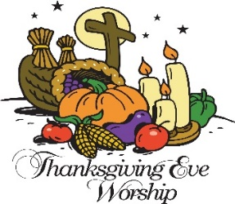
Addiction. Representatives from numerous Recovery organizations will be present to provide literature, guidance and answer questions. A time of honoring and remembering those who have passed by speaking their names
followed by placing a rose will take place. You need to call ahead to participate in this portion of the service. Please contact Sandy Caston 610-562-2972 ext. 202 for additional information.

2nd – Jennifer Schmeck
3rd – Leon Moyer, Lynn Phillips and Brantley Romig
4th - Jennifer Van Billiard
5th – Robin Reeder
8th – Jeanne Miller, Nikki Miller
9th – Amy Frantz and Joyce Strzelecki
10th – MaryEllen Beck and Glenn Helfrich
11th – June Fisher
14th – Tracey Epting and Andrew Loring
15th – Andrew Gangawere and Sheril Warmkessel
17th – Cindy Leamer
19th – Carole Eisenhard, Julie Fisher, Karen Kistler, Ron Leister and Mabel Reeder
20th – Michelle Stoudt
21st – Ashley Werst
22nd – Mona Boyer, Karen Epting, Livia Jacobs and Lance Plessl
23rd – Laraine Hamm and Dylan Pursell
25th Clifford Roth
30th – Daniel Haney

If your name is not on the birthday list, please contact the office so we can update our records. Although a birth year would be nice to complete our records, it is not necessary.
